COVID19 Pandemic – Hunger Relief Update
South Carolina Food Banks Key Statistics - August 2020
Because of the significant decrease in donated food, food purchases for the SC Food Banks almost immediately increased from an average of about $88,000 per month each to almost $700,000 – a 9x increase PER Food Bank.
Food banks rely heavily on donated product. Retail store pickups are way down due to lower inventory levels and the challenges of picking up food safely in a pandemic. That also means salvage is down as well. Without donated food, the Food Banks are forced to purchase food.
Local community Partner Agency closures have ranged from 20-50%, and currently are at about 20% closed, forcing Food Banks to step in.
Food banks depend on their network of hundreds of partner agencies to provide food at the local community level. Many partner agencies are predominantly managed by senior volunteers and cannot handle food in the normal way on pallets or cases - they need it in boxes. Meaning more boxes to pack with fewer people. Many agencies have temporarily closed, from positive testing or from senior volunteers that choose to stay home.
Currently, Food Banks are serving on average 30% more clients than before COVID19 - One third of the clients seen are new to receiving food assistance from a Food Bank.
Food Banks had an almost immediate increase in clients served of on average 57%, which has now settled into a 30% rate. The economic downturn has caused many citizens of SC to turn to the Food Banks for help.
SC Food Banks in June 2020 distributed over 7.2 million pounds of non-perishable food, as compared to 5.9 million in June 2019 – a 22% increase. Food Banks served 31% more households in June 2020 than in the comparable June 2019 timeframe.
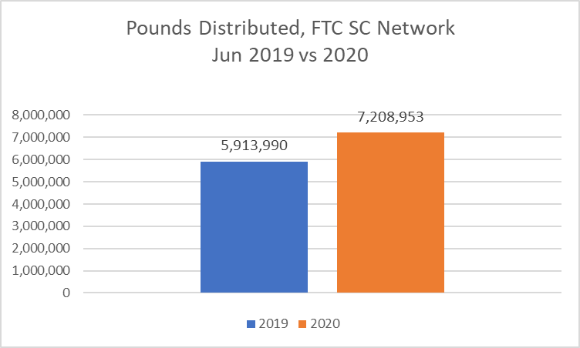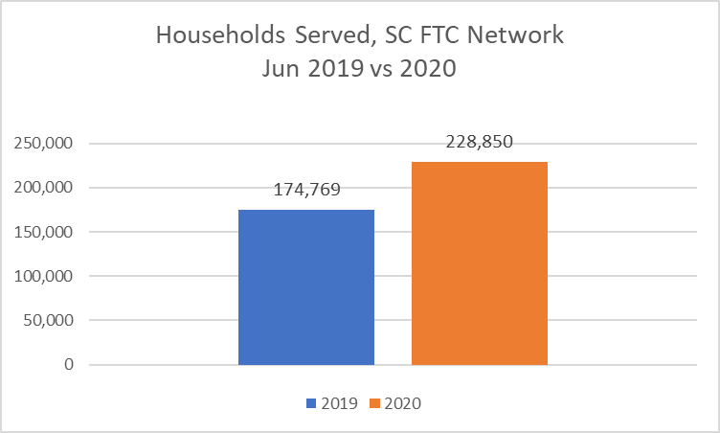
Note: The only federal COVID funding received by SC Food Banks has been restricted to logistics support for TEFAP (The Emergency Food Assistance Program) product. By way of comparison, as of August, NC Food Banks have received $6 million of CARES Act funds through their state legislature, and a second round of funding is actively being considered.

